Design Document

EasyWheelz

Mario Toshev

# 

Table of contents

**1. C4 architecture 2**

● C1 2

● C2 4

● C3 5

**2. Architecture constraints and design decisions 6**

# 

# C4 architecture

## C1

My application will be used by 2 types of users - Customers and company employees. It will be using an external API for saving the photos more efficiently.

## 

## C2

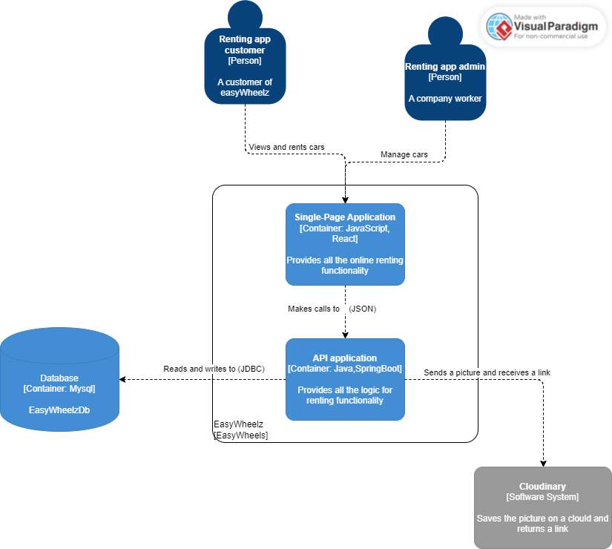

For this project the the technologies that will be used are MySql, SpringBoot and react.

1. MySQL is a popular relational database management system that is known for its stability, reliability, and scalability. It can handle large amounts of data and is widely used in enterprise applications.
2. Spring Boot is a popular Java-based framework for building web applications. It provides a number of tools and libraries that make it easy to develop and deploy applications quickly and efficiently.
3. React is a popular JavaScript library for building user interfaces. It is fast, efficient, and easy to use, and it can be used to create dynamic, interactive web applications.

## 

## C3

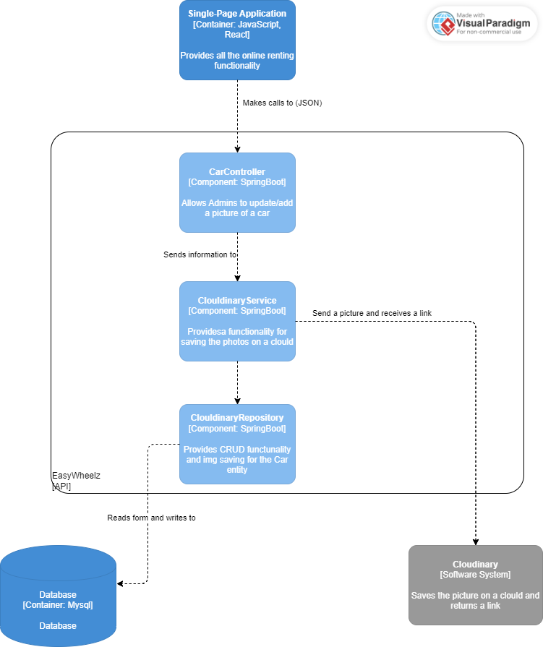

In the C3 I wanted to have a deeper look on how the connection with the external API is going to look like. The Service will be sending a photo to the API and after receiving the link it will send it to the Repository which will save it in the database. Here the single responsibility principle is used.

# Architecture constraints and design decisions

Together, the technologies mentioned(C2) can help create a full stack application that is both reliable and efficient, and that can scale to meet the needs of my users. MySQL is stable and efficient for storing and managing data, while Spring Boot provides a robust framework for building API. React provides a flexible and powerful frontend that allows to create dynamic and interactive user interfaces.